**Yellow Bird**

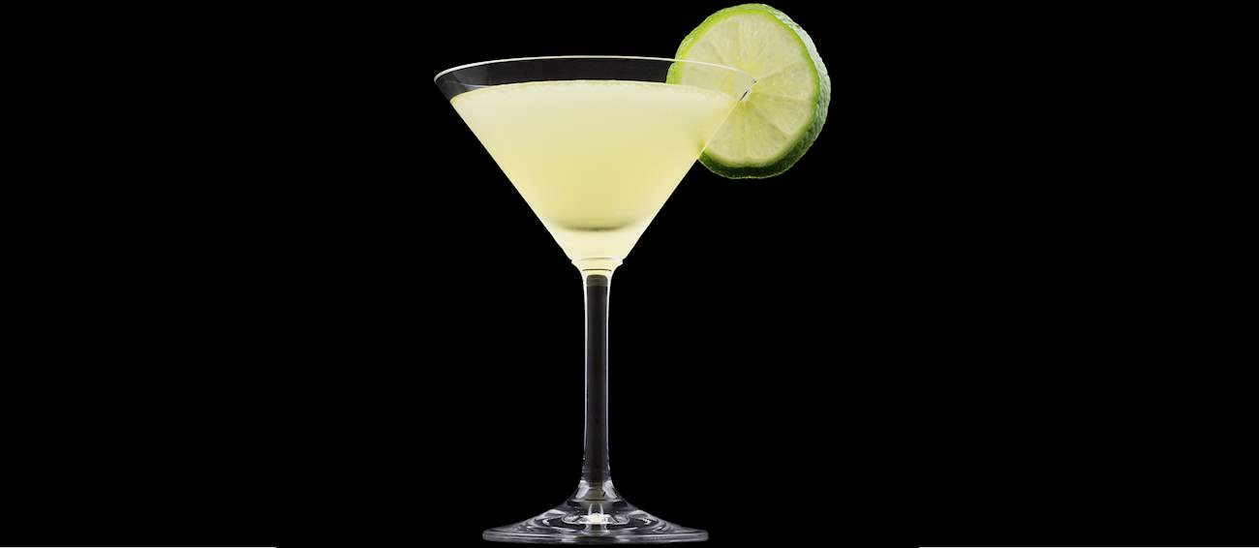

*Yellow Bird* is a tropical cocktail made with a combination of white rum, Galliano, triple sec, and fresh lime juice. In order to prepare it, all ingredients should be shaken and strained into a chilled cocktail glass. If desired, the cocktail can be garnished with a lemon slice.

The origins of Yellow Bird are still murky – some say the cocktail was named after the Haitian tune of the same name, while others say that it was named for its vibrant color, which is a result of adding Galliano, a golden, anise-flavored liqueur.